Multiple-choice section

|  |  |  |  |  |  |  |  |  |  |  |
| --- | --- | --- | --- | --- | --- | --- | --- | --- | --- | --- |
| Question | 1 | 2 | 3 | 4 | 5 | 6 | 7 | 8 | 9 | 10 |
| Answer | D | D | B | C | C | A | B | C | C | D |

Question 1 [3.1]

D

16 ÷ 8 = 2

 is 2 donuts

is 2 × 5 = 10 donuts

Question 2 [3.1]

D

= 12 ÷ 3 = 4

Question 3 [3.1]

B

Two squares = , two triangles =

Total area shaded =

Question 4 [3.2]

C

HCF of 24 and 60 is 12.

Question 5 [3.3]

C

The smallest ‘gap’ between one of the listed fractions and is ( + = ).

Question 6 [3.4]

A

=

=

Question 7 [3.4]

B

Both and are very close to 1, so their sum will be close to 2.

Question 8 [3.5]

C

of $35



Question 9 [3.6]

C

÷



Question 10 [3.7]

D



Multiple-choice total marks: 10

Short answer section

Question 11 2 marks [3.1]

(a) You *simplify* fractions by cancelling common factors in the numerator and denominator.

(b) *Proper fractions* are between 0 and 1.

Question 12 2 marks [3.2]

( × ) , (× )...   
Multiply numerator and denominator by the same whole number.

Question 13 1 mark [3.1]

Question 14 3 marks [3.2]

|  |  |  |
| --- | --- | --- |
| (a) | (b) | (c) |

Question 15 6 marks [3.3]

|  |  |  |
| --- | --- | --- |
| (a)   so is greater | (b)  is less than 1 whole. is less than 1 whole. is closer to 1 than  > | (c)  < |

Question 16 6 marks [3.5]

|  |  |  |
| --- | --- | --- |
| (a) – LCD = 10 = −  =  = | (b) + LCD = 18 = +  =  = | (c) LCD = 21 = 5 − 1 +  = 4 +  = 3 +  = 3 |

Question 17 6 marks [3.5]

|  |  |  |
| --- | --- | --- |
| (a) of $20  = $15 | (b) | (c)  = |

Question 18 6 marks [3.6]

|  |  |  |
| --- | --- | --- |
| (a)  =  =  = 6 | (b)  = | (c)  = |

Question 19 4 marks [3.7]

|  |  |
| --- | --- |
| (a) 5 + | (b) |

Short answer total: 36

Extended answer section

Question 20 9 marks [3.1, 3.2, 3.3]

(a) 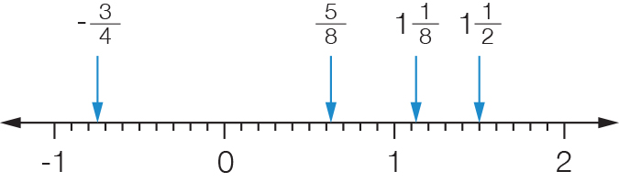

(b)  

(c)  is located just to the left of 1 on the number line, between  and 1. The closest number is , less than  away.  is more than away.

(d) -is the only negative number, so it is the smallest.  
 and then are the two proper fractions.  
is next as =  and .  
Order is: 

(e)  and   
There are four whole numbers between (2, 3 and 4 and 5).

Question 21 9 marks [3.4, 3.5, 3.6]

|  |  |  |
| --- | --- | --- |
| (a) 1 +  = 1 +  = 1 = 2 | (b) 2× 10 | (c) 10 ÷  = 10 ÷  =  = =  No, 1 packet (10 cups) of flour is only enough for cakes. |

Extended answer total: 18

TOTAL test marks: 64